##### PES Institute Of Technology And Management

NH 206, Shimoga

**DEPARTMENT OF COMPUTER SCIENCE AND ENGINEERING**

Mini Project onDatabase Management System (18CS53)

**“College ERP System”**

### Mini project report submitted in partial fulfillment of curriculum prescribed for the Database Management Systems (18CS53) course for the award of the degree of

##### BACHELOR OF ENGINEERING IN

##### COMPUTER SCIENCE AND ENGINEERING

#### by

***Pramod D Preetham S.P***

**(4PM18CS062) (4PM18CS064)**

#### Under the Guidance of

**Mr. Raghavendra Sir**

Assistant Professor,

Dept.of CSE,

PESITM – SHIMOGA

##### J S S Mahavidyapetha

##### JSS Science and Technology University Mysuru-570009, Karnataka,India



**DECLARATION**

We Dakshath, Nikhil, Anudeep, Samarth students of 5th Semester B.E ,Computer Sci- ence & Engineering at JSS Science and Technology University, Mysuru hereby declare that this group activity was carried out by our group and this report was prepared by us as a part of the course work CS510- Database Management Systems under the guidance of Prof. Dr. Manimala S.

##### Place: Mysuru Date: 22/11/2018

**Abstract**

This report specifies the various processes and techniques used in gathering requirements, designing, implementing and testing for the project on college management system. The problems regarding the current system in the college were analyzed and noted. This project aims to solve some of those problems and thus, add more value to the current system. The requirements were gathered from all the stakeholders and based on that we created a requirements models and designed the software. The project was implemented in the form of a website using django(python).

Using the various resources and tools we gathered along the way, we implemented the college ERP system using some features that solve the current problems in the system such as a provision to edit the attendance and marks before locking it at the end. The software was also tested using the various testing methods and results were positive.

Thus, the results can be integrated in the current ERP system to improve it’s working and solve some of the existing problems.

**Acknowledgment**

First, we would like to thank PES Institute of Technology for implementing Database Management Systems as a subject for our course.

We would also like to thank our Database Management Systems Professor Mr. Raghvendra Sir for giving us an opportunity to do this project about College ERP.

At last we would like to thank all the our team members who were involved directly or in- directly in collecting the requirements.

- Pramod D

- Preetham S

**Contents**

1. Introduction 6

1.1 Identification . . . . . . . . . . . . . . . . . . . . . . . . . . . . . . . . . 6

1.2 Purpose . . . . . . . . . . . . . . . . . . . . . . . . . . . . . . . . . . . . 6

1.3 Scope . . . . . . . . . . . . . . . . . . . . . . . . . . . . . . . . . . . . . 6

1.4 Definitions, Acronyms, and Abbreviations . . . . . . . . . . . . . . . . . 7

1.5 References . . . . . . . . . . . . . . . . . . . . . . . . . . . . . . . . . . . 7

1.6 Overview and Restriction . . . . . . . . . . . . . . . . . . . . . . . . . . . 8

1. Overall Description 9

2.1 Product Perspective . . . . . . . . . . . . . . . . . . . . . . . . . . . . . 9

2.2 Product Features . . . . . . . . . . . . . . . . . . . . . . . . . . . . . . . 9

* 1. User Classes and Characteristics . . . . . . . . . . . . . . . . . . . . . . . 9
  2. Operating Environment 10

1. Requirements 11
   1. Expected requirement: Student and staff information 11
   2. Normal requirement: Attendance and marks entry 11
   3. Exciting requirement: Communication among students and teachers 11
2. External Interface Requirements 12
   1. User Interfaces 12
   2. Hardware Interfaces 12
   3. Software Interfaces 12
   4. Communications Interfaces 12
3. Non-functional requirements 13
   1. Safety requirements 13
   2. Security requirements 13
   3. Software Quality Attributes 13
4. System Design 14
   1. Student 14
   2. Teacher 14
   3. Administrator 15
   4. Use Case Diagram 16
   5. Class Diagram 17
   6. Entity Relationship Diagram 18
5. Implementation details 19
   1. Architectural model 19
   2. Mathematical model 21

|  |  |  |
| --- | --- | --- |
| **8** | **Modules in the system** | **23** |
|  | 8.1 Student . . . . . . . . . . . . . . . . . . . . . . . . . . . . . . . . . . . . | 23 |
|  | 8.2 Login . . . . . . . . . . . . . . . . . . . . . . . . . . . . . . . . . . . . . . | 23 |
|  | 8.2.1 Homepage . . . . . . . . . . . . . . . . . . . . . . . . . . . . . . . | 23 |
|  | 8.2.2 Attendance . . . . . . . . . . . . . . . . . . . . . . . . . . . . . . | 23 |
|  | 8.2.3 Attendance Detail . . . . . . . . . . . . . . . . . . . . . . . . . . | 23 |
|  | 8.2.4 Marks . . . . . . . . . . . . . . . . . . . . . . . . . . . . . . . . . | 23 |
|  | 8.2.5 Timetable . . . . . . . . . . . . . . . . . . . . . . . . . . . . . . . | 24 |
|  | 8.3 Teacher . . . . . . . . . . . . . . . . . . . . . . . . . . . . . . . . . . . . | 24 |
|  | 8.3.1 Login . . . . . . . . . . . . . . . . . . . . . . . . . . . . . . . . . . | 24 |
|  | 8.3.2 Homepage . . . . . . . . . . . . . . . . . . . . . . . . . . . . . . . | 24 |
|  | 8.3.3 Attendance . . . . . . . . . . . . . . . . . . . . . . . . . . . . . . | 24 |
|  | 8.3.4 Enter Attendance . . . . . . . . . . . . . . . . . . . . . . . . . . . | 24 |
|  | 8.3.5 Edit Attendance . . . . . . . . . . . . . . . . . . . . . . . . . . . | 25 |
|  | 8.3.6 Extra Class . . . . . . . . . . . . . . . . . . . . . . . . . . . . . . | 25 |
|  | 8.3.7 Student Attendance . . . . . . . . . . . . . . . . . . . . . . . . . . | 25 |
|  | 8.3.8 Student Attendance Details . . . . . . . . . . . . . . . . . . . . . | 25 |
|  | 8.3.9 Marks . . . . . . . . . . . . . . . . . . . . . . . . . . . . . . . . . | 25 |
|  | 8.3.10 Enter Marks . . . . . . . . . . . . . . . . . . . . . . . . . . . . . . | 25 |
|  | 8.3.11 Edit Marks . . . . . . . . . . . . . . . . . . . . . . . . . . . . . . | 26 |
|  | 8.3.12 Student Marks . . . . . . . . . . . . . . . . . . . . . . . . . . . . | 26 |
|  | 8.3.13 Timetable . . . . . . . . . . . . . . . . . . . . . . . . . . . . . . . | 26 |
|  | 8.3.14 Free teachers . . . . . . . . . . . . . . . . . . . . . . . . . . . . . | 26 |
|  | 8.3.15 Reports . . . . . . . . . . . . . . . . . . . . . . . . . . . . . . . . | 26 |
|  | 8.4 Administrator . . . . . . . . . . . . . . . . . . . . . . . . . . . . . . . . . | 27 |

##### Screenshots of the implemented system 28

##### Conclusion and future work 38

##### References 39

# Introduction

Enterprise Resource Planning system, popularly known as ERP system, the descendant of MRPII offers the answer to the economic and productivity troubles of manufacturing and service enterprises. Thus, the ERP system has become very popular as an enterprise management software tool. It was the larger companies that have opted to use the ERP systems initially. However, the use of ERP has changed and today the term can refer to any type of company, no matter what industry it falls in. In fact, ERP systems are used in almost any type of organization - large or small. The latest ERP tools available in the market today can cover a wide range of functions and integrate them into one unified database. This made ERP to land up into higher educational institutes. In today’s competitive business world usage of ERP system is becoming a must for any educational organization to meet the challenges faced in their business process and to have a cutting edge. Studies also reveal that organizations that don’t have an ERP implemented are facing numerous problems in their internal processing like attendance management, payroll management, quick decision making, etc. So in order to be different and ready for action the institutes need a central resource planning that can manage the entire information and operations of the institutions.

## Identification

The software system being considered for development is referred to as College ERP Sys- tem. The customer providing specifications for the system are prof.Manimala, prof.Divakar and students, Department of CSE SJCE. The ultimate customer, or end-user, of the system will be the teachers and the HoDs of each department in SJCE, Students and Administrators. This is a new project effort, so the version under development is version 1.0.

## Purpose

The purpose is to design software for college database which contains up to date or accu- rate information of the college. That should improve efficiency and flexibility of college record management and to provide a common and or simple platform for everyone to ac- cess the student’s information.College Automation System consists of different modules such as student, faculty, admin etc. Our main purpose is to create a software which will manage the working of these different modules. The interconnectivity among modules reduces the time to perform different operational task.

## Scope

College management is becoming a very essential component in education in this modern day age. With the help of College Automation System we can gather all the useful information needed to the management in few clicks. The College ERP system now computerizes all the details that are maintained manually. Once the details are fed into the system or computer there is no need for various persons to deal with separate sections.

Only a person is enough to maintain all the reports and records. The security can also be given as per the user requirement.

## Definitions, Acronyms, and Abbreviations

**SJCE** Sri Jayachamarajendra College of Engineering, an Au- tonomous Engineering College, affiliated to Vishweswarayya Technological University(VTU), Belagum and located in My- suru, which offeres full time and part time engineering courses, to award Bachelor of Engineering (BE) degree. It also offers several other degrees including, but not limited to MTech and MSc. The customer of current product. Refered as ’the col- lege’ hereafter

*•*

**Department** The educational sub bodies of the college, which can offer sev- eral Programmes and Courses. Each department is managed by a HoD (Head of the Department)

*•*

**Course** The subject offered by a Department in a semester, which is compulsary for a Student to take in order to make him/her eligible for SEE, and subsequently, award of BE Degree.

*•*

**Semester** The 5 Month (or 2 month, in case of supplementary) Duration in student is offered a set of courses by a department and the courses are conducted in a part time or full time fashion. Each academic year consists of 3 semesters, out of which 2 are regular and 1 is supplementary.

*•*

**CIE** Continuous Internal Evaluation, series of examinations con- ducted throughout the semester to assess the academic per- formance of the student. CIE conducted in the form of events (Usually 5). Finally, CIE is reduced to a total of 50 marks

*•*

**SEE** Semester End Examination, conducted at the end of each semester to asses the academic performance of the student. Conducted for 100 marks and reduced to 50 marks.

*•*

## References

* + - Software Engineering-A Practitioners approach by Roger S Pressman
    - Fundamentals of database systems by Ramez Elmarsi and Shamkant Navathe

## Overview and Restriction

This document is for limited release only to personnel working on the project and the project mentors and reviewers.

Chapter 2 of this document describes the system under development from a holistic point of view. Functions, characteristics, constraints, assumptions, dependencies, and overall requirements are defined from the system-level perspective.

Chapter 3 of this document describes the interfaces of the system being developed. They impose guidelines on the design of the product being developed.

Chapter 4 of this document describes the Functional Requirements of the system being developed. Functional Requirements are categorized on the basis of System Features. They are enumerated and described to a degree sufficient for a knowledgeable designer or coder to begin crafting an architectural solution to the proposed system.

Chapter 5 of this document describes the Non Functional Requirements of the sys- tem being developed. They are critical for the working for the system. Designer and Imple- menters should make sure that all the Non Functional Requirements are satisfied.

Appendix A covers the Glossary, which defines some abbreviations and terms used in document, which are not covered in Introduction.

Appendix B includes all reference models such as Schema Diagram. Designers can refer Appendix B and craft the software accordingly.

# Overall Description

## Product Perspective

ERP means the techniques and concepts for integrated management of business as a whole, from the viewpoint of effective use of management resources to improve the ef- ficiency of enterprise management. A fully integrated web-based ERP will capture and create accurate, consistent and timely relevant data, and assist in intelligent business decision-making. The primary purpose of E-college is to provide mechanisms for au- tomated processing and management of the entire institution. It reduces data error, ensures that information is managed efficiently and is always up-to-date. Complete stu- dent histories for all years, can easily be searched, viewed and reported on press of button.

It is made after extensive study of all the departments like student, faculty, etc of col- leges and is provided with the extract of everything a college requires for their database handling, department management and student/staff management. The security issue within ERP has been there for a long time, but most of the solutions are based on the as- sumption that an ERP system is a closed environment. Higher education institutions are persisting in the IS era by adopting and implementing ERP system.The need to evaluate their benefits and impacts on organizations and individuals are increasingly essential.

## Product Features

Each teacher will be able to enter attendance and marks for their respective stu- dents.

*•*

* + - Each student will be able to view the attendance status for their respective courses.

The teachers will be able to apply for various types of leave directly through the system.

*•*

* + - The students will be able to Communicate and provide feedback to their teachers.

The students will have access to a forum page where they are communicate will each other.

*•*

The administrator will be able to view and update information such as departments, classes, teachers, students, courses.

*•*

## User Classes and Characteristics

There are several types of end users for the college ERP system. They are broadly di- vided as Students, Staff and the Administrator. Each of these classes have their own set of features.

The student should have the following features:

* + - View the Attendance status of the courses to which they are enrolled.
    - View the Marks of the courses to which they are enrolled.
    - View the notification from the college administrator.
    - Communicate or give feedback to their respective teachers.
    - Communicate with other students of the same university.

The staff should have the following features:

* + - Access to the information of all students that attend their courses.
    - Add and edit the Attendance status of those students.
    - Add and edit the exam marks of those students.
    - Avail the different types of leave.
    - Swap classes with other teachers who teach for the same class.

The administrator should have the following features:

* + - Add and update students, teachers and courses.
    - Assign teachers and students to courses

## Operating Environment

The operating environment for College ERP system are listed below:

* + - Operating System: Windows 10
    - Database: MySQL database
    - Front end: HTML/CSS/Bootstrap
    - Back end: Django

# Requirements

## Expected requirement: Student and staff information

**Description and priority** Information regarding students, teachers and courses are stored in the database. Every user can view only certain information based on their user class. For example, a teacher can view student and course information that they are handling. This feature is of high priority as the information must be viewed by only the authorized users.

##### Functional requirements

Each user shall be able to view information in the database based on their user class.

*•*

* + - The administrator shall be able to view all the information in the database.

## Normal requirement: Attendance and marks entry

**Description and priority** Attendance and marks entry is the main feature of the Col- lege ERP system. Hence, the priority is high. Teachers update the attendance and marks of the students who are part of her class. Students can view their respective Attendance and marks of the courses they have taken.

##### Functional requirements

Teachers shall be able to view, update and edit the attendance and marks of the students, part of their class.

*•*

* + - Teacher shall be able to take extra classes, switch classes with other teachers.

## Exciting requirement: Communication among students and teachers

**Description and priority** Students and teacher will be able to communicate with each other directly using the ERP system. Students may give their queries and feedback to a teacher and they may respond accordingly. The priority of this feature is low as cost of implementation could be very high. A simple version of this feature is to be implemented.

##### Functional requirements

Students shall be able to communicate with their teachers by sends personal mes- sages.

*•*

* + - Students shall be able to communicate with other students through a forum section.

# External Interface Requirements

## User Interfaces

The User interface is made using Bootstrap. Firstly, there will be a simple login page separate for students and teachers. Each student and teacher will have a unique interface. There will be a fixed sidebar with links to all the modules. The teachers will be able to view their respective students and update their attendance and marks using an effortless interface.

## Hardware Interfaces

Since neither the mobile application nor the web portal have any designated hardware, it does not have any direct hardware interfaces. Any browser can be used to access the webapp.

## Software Interfaces

The following is a list of software used in making of the project.

Operating System: We have chosen Windows operating system for its best support and user-friendliness.

*•*

Django: We have chosen to use Django for the back-end of the website as Django is a simple python framework and is suitable for beginners.

*•*

* + - Database: We are using SQLite database, which comes as default with Django.

## Communications Interfaces

This project is to be deployed an online website. All the users can connect to the database server from anywhere and have access to their information.

# Non-functional requirements

## Safety requirements

If there is extensive damage to a wide portion of the database due to catastrophic failure, such as a disk crash, the recovery method restores a past copy of the database that was backed up to archival storage (typically tape) and reconstructs a more current state by reapplying or redoing the operations of committed transactions from the backed-up log, up to the time of failure.

## Security requirements

The database contains sensitive information of all the students and staff. Therefore, optimal security measures must be taken to ensure data is safe from unauthorized users.

## Software Quality Attributes

**Availability:** The users must always be able to view their information so that they can keep track regularly.

**Correctness:** The information about attendance and marks must be correct to not feed wrong information to the users.

**portability:** The users access the ERP from various platforms such as desktops and mobile phones. The webapp must be portable to all platforms and the user experience must be optimal.

# System Design

Various Design concepts and processes were applied to this project. Following concepts like separation of concerns, the software is divided into individual modules that are functionally independent and incorporates information hiding. The software is divided into 3 modules which are students, teachers and administrators. We shall look at each module in detail.

## Student

Each student belongs to a class identified by semester and section. Each class belongs to a department and are assigned a set of courses. Therefore, these courses are common to all students of that class. The students are given a unique username and password to login. Each of them will have a different view. These views are described below.

##### Student information

*•*

Each student can view only their own personal information. This includes their personal details like name, phone no, address etc. Also, they can view the courses they are enrolled in and the attendance, marks of each of those.

##### Attendance information

*•*

Attendance for each course will be displayed. This includes the number of attended classes and the attendance percentage. If the attendance percentage if below a specified threshold, say 75%, It will be marked in red otherwise it be in green. There will also be a day wise attendance view for each course which shows the date and status. This will be presented in a calender format.

##### Marks information

*•*

There will be 5 events and 1 semester end examination for each course. The marks for each of these will be provided in the ERP system.

##### Notifications and events

*•*

This section is common to all students. Notification are messages from the admin such as declaration of holidays, test time-table etc. The events and their details are specified here.

## Teacher

Each teacher belongs to a department and are assigned to classes with a course. Teachers will also have a username and password to login. The different views for teachers are described below.

##### Information

*•*

The teachers will have access to information regarding the courses and classes they are assigned to. Details of the courses include the credits, the syllabus plan. Details of the class include the department, semester, section and the list of students in

each class. The teacher will also have access to information of students who belong to the same class as as the teacher.

##### Attendance

*•*

The teacher has the ability to add and also edit the attendance of each student. For entering the attendance, they will be given the list of students in each class and they can enter the attendance of the whole class on a day to day basis. There will be two radio buttons next to each student name, one for present and the other for absent. There will also be an option for extra classes. Teachers can edit the attendance of each student either for each student individually or for the whole class.

##### Marks

*•*

The teacher can enter the marks for the 5 events and 1 SEE for each course they are assigned. They also have the ability to edit the marks in case of any changes. Reports such as the report card including all the marks and CGPA of a student can be generated.

## Administrator

The administrator will have access to all the information in the different tables in the database. They will access to all the tables in a list form. They will be able to add a entry in any table and also edit them. The design of the view for the admin will provide a modular interface so that querying the tables will be optimized. They will be provided with search and filter features so that they can access data efficiently.

## Use Case Diagram

A use case diagram at its simplest is a representation of a user’s interaction with the system that shows the relationship between the user and the different use cases in which the user is involved. A use case diagram can identify the different types of users of a system and the different use cases and will often be accompanied by other types of diagrams as well. The use cases are represented by either circles or ellipses.

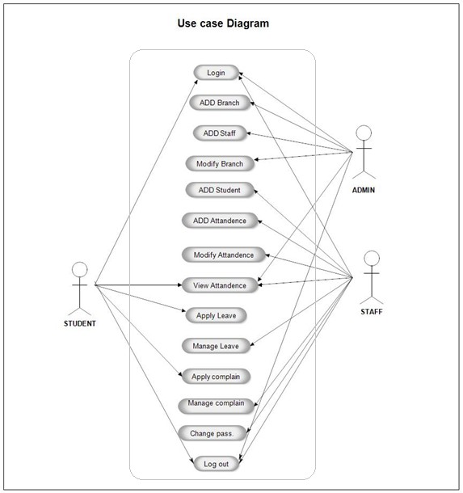

Figure 1: Use Case Diagram of college ERP

## Class Diagram

The class diagram states the different classes involved in the software. For each class, a set of attributes and method are included. The relationship between the classes are also specified. For example, the teacher class has the attributes Id, name, phone no, address and methods such as marking attendance, declaring marks and preparing report cards. Each instance of the teacher class belongs to a department. This is specified by the relationship between Teacher and Department classes.

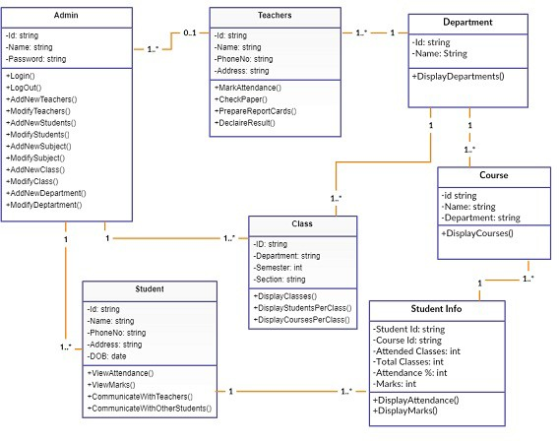

Figure 2: Class diagram of college ERP

## Entity Relationship Diagram

An entity relationship diagram (ERD) shows the relationships of entity sets stored in a database. An entity in this context is an object, a component of data. An entity set is a collection of similar entities. These entities can have attributes that define its properties.

By defining the entities, their attributes, and showing the relationships between them, an ER diagram illustrates the logical structure of databases. ER diagrams are used to sketch out the design of a database.

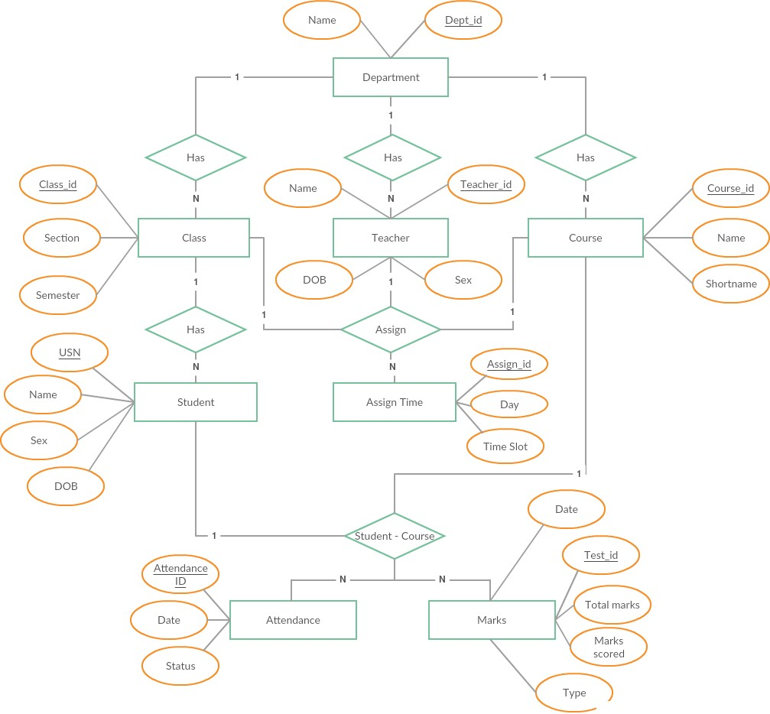

Figure 3: Entity Relationship diagram of college ERP

# Implementation details

## Architectural model

The ERP software requires the architectural design to represent the design of the software. Here we define a collection of hardware and software components and their interfaces to establish the framework for the development of this software.

There exists number of components of the system which are integrated to form a system. The set of connectors will help in coordination, communication, and cooperation between the components. The ERP software is built for computer-based system. It exhibits the data centric style of architecture.

The architecture comprises of various modules as given in the figure. There are 3 major categories in which the whole architecture is divided. These are administrator, staff and student. The architecture is designed such a way that it is self explanatory. The admin roles are user management, staff management, student management, staff attendance. Staff and admin perform some common functions like news management, leave management, time table management, exam management.

The role of staff includes student attendance entering, student examination man- agement, time table management, leave application management, and put on news on e-notice board. While the roles of students are few in number and includes their complete

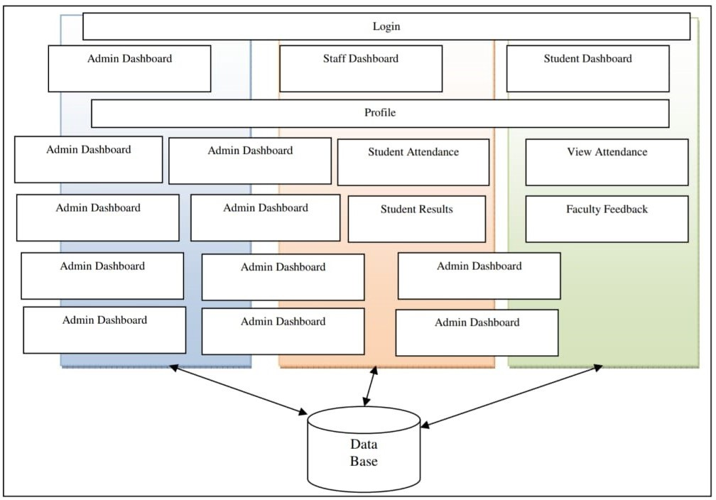

Figure 4: architecture

profile viewing, view their attendance, give feedback to their respective faculties, view notice and view academic time table.

Generalizing E-college architecture is 3 tiers. The 3 tiers comprises of presentation layer, application logic layer and data layer.

Any Information System needs to communicate with external entities, human users or other computers. Presentation layer allows these entities to interact with the system; it can also be implemented as a GUI interface and can be referred to as the client of the IS.

Application layer do more than information delivery, they perform data processing (Busi- ness Logic and calculation) behind the results being delivered. This tier is often referred as

1.Services 2.Business rules 3.Business logic 4.Servers

The database layer is implemented using a Database Management System which in our case is MySql.

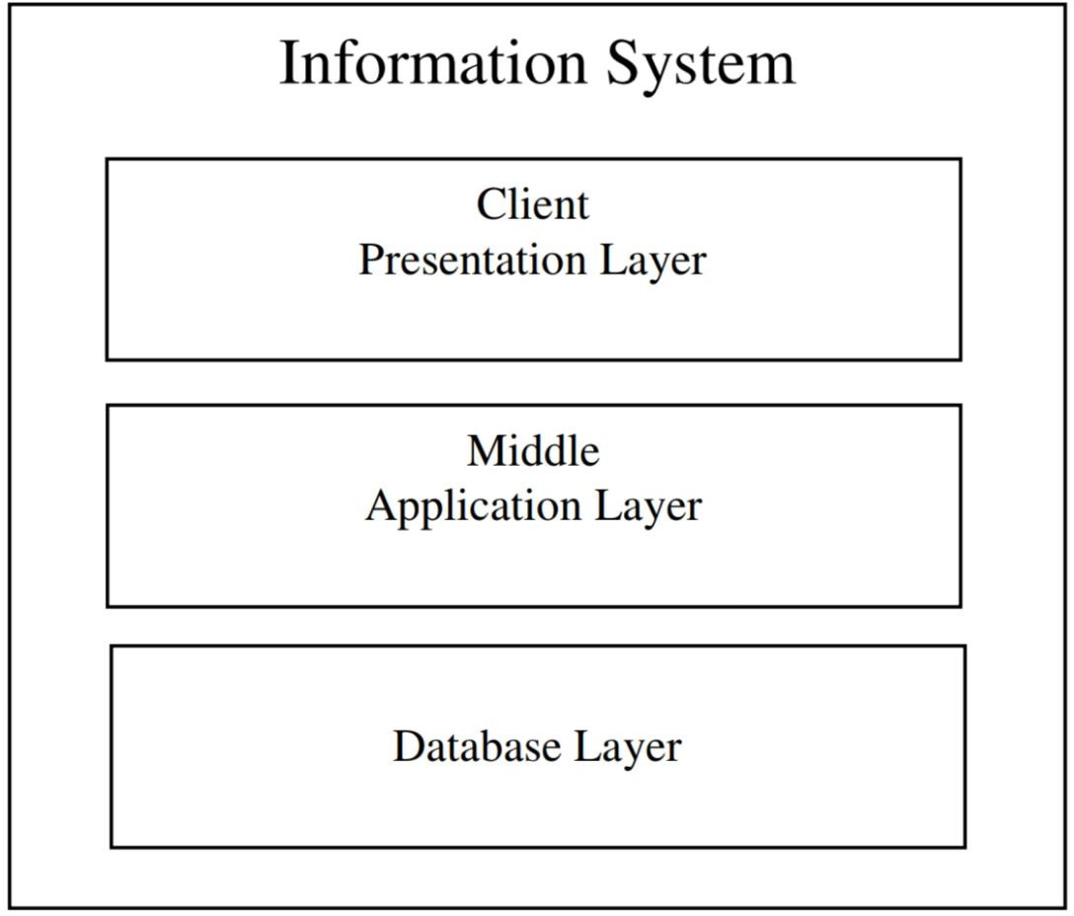

Figure 5: 3 tier architecture

## Mathematical model

Finite State Machine (FSM) for E-college ERP:

A change from one state to another when initiated by a triggering event or condition; this is called a transition. A particular FSM is defined by a list of its states, and the triggering condition for each transition.

As there are no mathematical calculations to be implemented in our project thus we have designed this FSM for our E- college. The Fig below shows the states and path which describes the flow E-College. It consists of M-set of tuples, Q-set of states, q0- Initial state, and F-final state.

M= (Q, Σ, *δ*, q0, F)

Q:q0,q1,q2,q3,q4,q5,q6,q7,q8,q9,q10,q11 E: 1, 2, 3...16

q0: Homepage F: Homepage

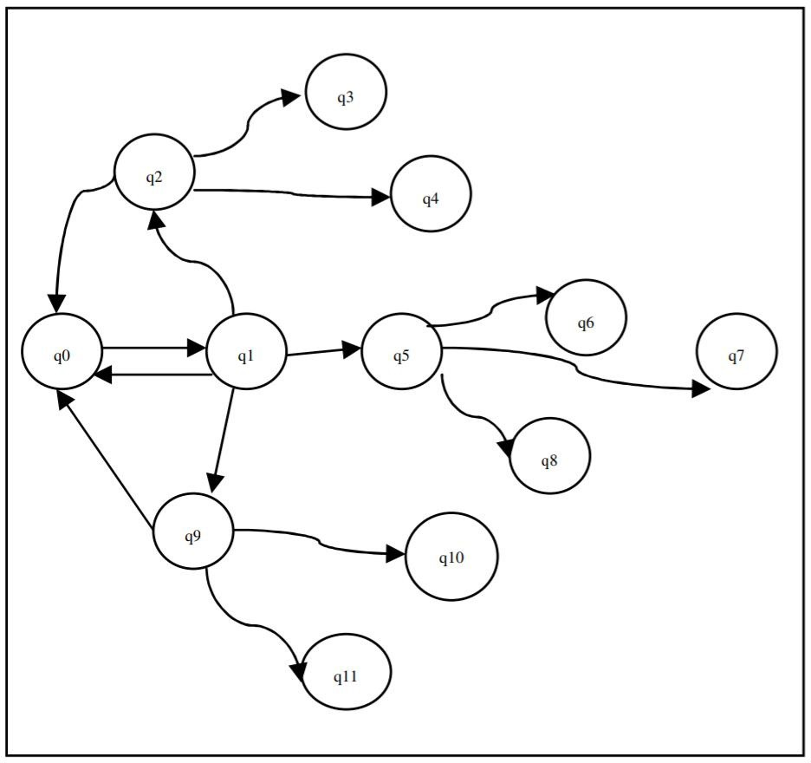

Figure 6: finite state machine

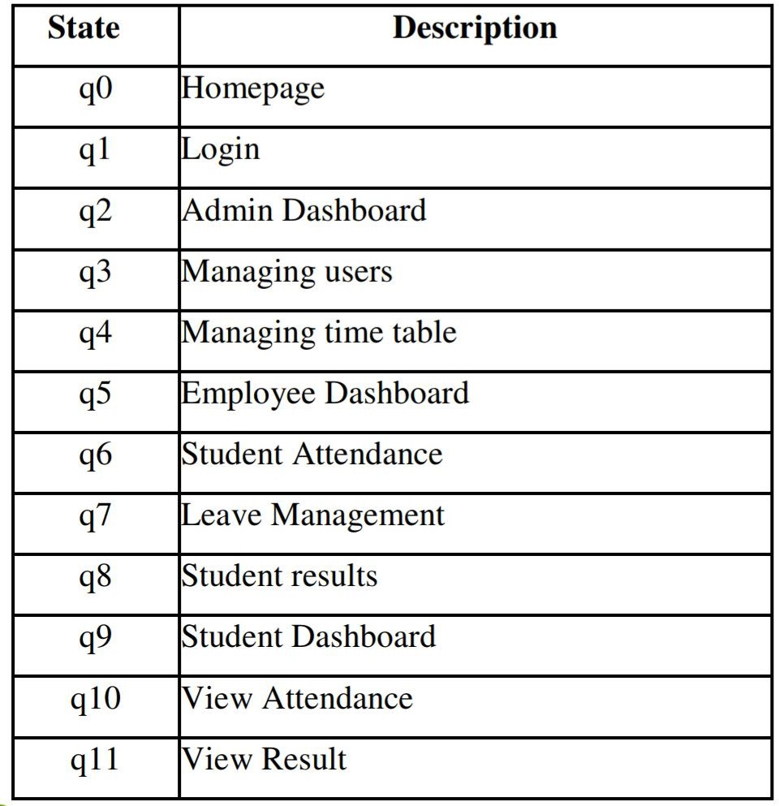

Figure 7: finite state machine description

# Modules in the system

The college ERP system has three main user classes. These include the students, teachers and administrator. This section will explain in detail all the features and the working of those for each user class.

* 1. **Student**
  2. **Login**

Each student in the college is assigned a unique username and password by the admin- istrator. The username is the same as their USN and so is the password. They may change it later according to their wish.

##### Homepage

After successful login, the student is presented a homepage with their main sections, attendance, marks and timetable. In the attendance section the student can view their attendance status which includes the total classes, attended classes and the attendance percentage for each of their courses.

In the marks section, the student can view the marks for each of their courses out of 20 for 3 internal assessments, 2 events. Also, the semester end examination for 100 marks. Lastly, the timetable provides the classes assigned to that student and day and time of each in a tabular form.

##### Attendance

On the attendance page, there is a list of courses that is dependent on each student. For each course, the course id and name are display along with the attended classes, total classes and the attendance percentage for that particular course. If the attendance per- centage is below 75 for any course, it is displayed in red denoting shortage of attendance, otherwise it is green. If there is any shortage, it specifies the number of classes to attend to make up for it. If you click on each course, it takes you to the attendance detail page.

##### Attendance Detail

This page displays more details for the attendance in each course. For each the course, there is a list of classes conducted and each is marked with the date, day and whether the student was present or absent on that particular date.

##### Marks

The Marks page is a table with an entry for each of their courses. The course id and name are specified along the marks obtained in each of the tests and exams. The tests

include 3 internal assessments with marks obtained out of a total of 20, 2 events such as project, assignment, quiz etc., with marks out of 20. Lastly, one semester end exam with marks out of 100.

##### Timetable

This page is a table which lists the day and timings of each of the classes assigned to the student. The row headers are the days of the week and the column headers are the time slots. So, for each day, it specifies the classes in the time slots. The timetable is generated automatically from the assign table, which is a table containing the information of all the teachers assigned to a class with a course and the timings the classes.

* 1. **Teacher**

##### Login

Each teacher in the college is assigned a unique username and password by the adminis- trator. The username is their teacher ID and the same for password. The teacher may change the password later.

##### Homepage

After successful login, the student is presented a homepage with their main sections, attendance, marks, timetable and reports. In the attendance section, the teacher can enter the attendance of their respective students for the days on which classes were conducted. There is a provision to enter extra classes and view/edit the attendance of each individual student. In the marks section, the teacher may enter the marks for 3 internals, 2 events and 1 SEE for each student. They can also edit each of the entered marks. The timetable provides the classes assigned to the teacher with the day and timings in a tabular form. Lastly, the teacher can generate reports for each of their assigned class.

##### Attendance

There is a list of all the class assigned to teacher. So, for each class there are 3 actions available. They are,

##### Enter Attendance

On this page, the classes scheduled or conducted is listed in the form of a list. Initially, all the scheduled classes will be listed from the start of the semester to the current date. Thus, if there is class scheduled for today, it will automatically appear on top of the list. If the attendance of any day is not marked it will be red, otherwise green if marked. Classes can also be cancelled which will make that date as yellow. While entering the attendance, the list of students in that class is listed and there are two options next to each. These options are in the form of a radio button for present and absent. All

the buttons are initially marked as present and the teacher just needs to change for the absent students.

##### Edit Attendance

After entering attendance, the teacher can also edit it. It is similar to screen for entering attendance, only the entered attendance is saved and display. The teacher can change the appropriate attendance and save it.

##### Extra Class

If a teacher has taken a class other than at the scheduled timings, they may enter the attendance for that as well. While entering the extra class, the teacher just needs to specify the date it was conducted and enter the attendance of each of the students. After submitting extra class, it will appear in the list of conducted classes and thus, it can be edited.

##### Student Attendance

For each assigned class, the teacher can view the attendance status of the list of students. The number of attended classes, total number of classes conducted and the attendance percentage is displayed. If the attendance percentage of any of the students is below 75, it will be displayed in red. Thus, the teacher may easily find the list of students not eligible to take a test.

##### Student Attendance Details

The teacher can view the attendance detail of all their assigned students individually. That is, for all the conducted classes, it will display whether that student was present or absent. The teacher can also edit the attendance of each student individually by changing the attendance status for each conducted class.

##### Marks

On this page, the list of classes assigned to the teacher are displayed along with two actions for each class. These actions are,

##### Enter Marks

On this page, the teacher can enter the marks for 3 internal assessments, 2 events and one semester end exam. Initially all of them are marked red to denote that the marks have not been entered yet. Once the marks for a test is entered, it turns green. While entering the marks for a particular test, the list of students in that class is listed and marks can be entered for all of them and submitted. Once, the marks are submitted, the students can view their respective marks. Incase if there is a need to change the marks of any student, it is possible to edit the marks.

##### Edit Marks

Marks for a test can be edited. While editing, the list of students in that class is dis- played along with already entered marks. The marks to be updated can be changed and submitted. The students can view this change immediately.

##### Student Marks

For each assigned class, the teacher has access to the list of students and the marks they obtained in all the tests. This is displayed in a tabular form.

##### Timetable

This page is a table which lists the day and timings of each of the classes assigned to the teacher. The row headers are the days of the week and the column headers are the time slots. So, for each day, it specifies the classes in the time slots. The timetable is generated automatically from the assign table, which is a table containing the information of all the teachers assigned to a class with a course and the timings the classes.

##### Free teachers

For each entry in the table, the list of free teachers can be generated. Free teachers are the teachers who assigned to the class and are free for that time slot on that day. This is very useful for the teachers particularly when they are on leave as it helps them find a suitable replacement are that class.

##### Reports

The last page for the teachers is used to generate reports for each class. The report spec- ifies the list of students in that class and their respective CIE and attendance percentage. CIE is the average of the marks obtained from the tests, 3 internals and 2 events. The CIE is out of 50 and the students with CIE below 25 are marked in red and are not eligible to write the semester end exam. Also, the attendance percentage is displayed with students below 75% marked in red.

* 1. **Administrator**

The administrator is responsible for adding and maintaining all the departments, stu- dents, teachers, classes and courses. All this data is stored in the database in their respective tables. The admin is also responsible for adding and maintaining the list of teachers assigned to class with a course and the timings. This information is stored in the Assign table. The admin also has access to the marks and attendance of each student and can modify them.

There are several features in place to ensure that querying the database is quick and efficient for the administrator. As the database has the potential to become huge, there is a search feature for every table including student, teacher etc. The search has get a specific record based on name or id. Also, it can filter the record based on department, class etc.

1. **Screenshots of the implemented system**

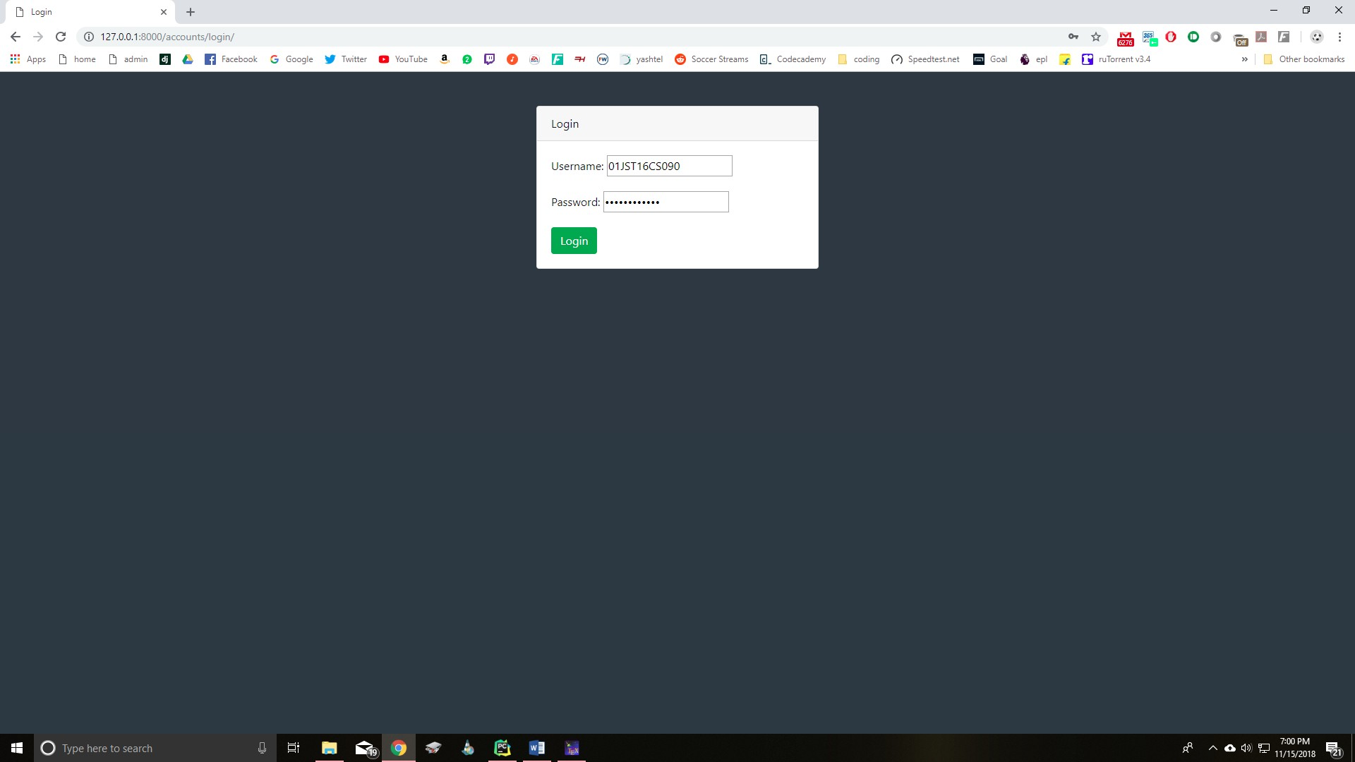

Figure 8: Student Login Page

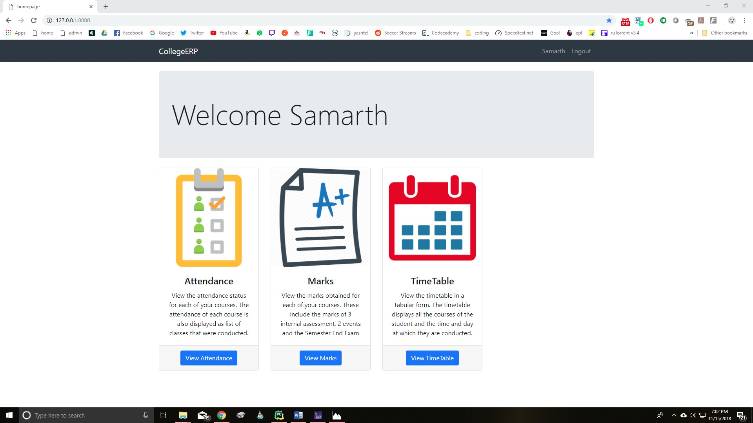

Figure 9: Student Home Page

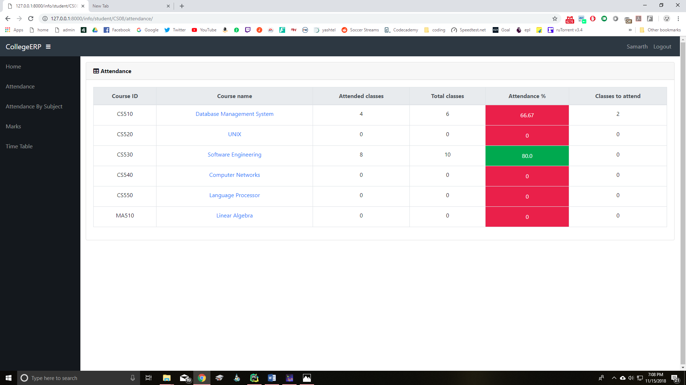

Figure 10: Student Attendance Page

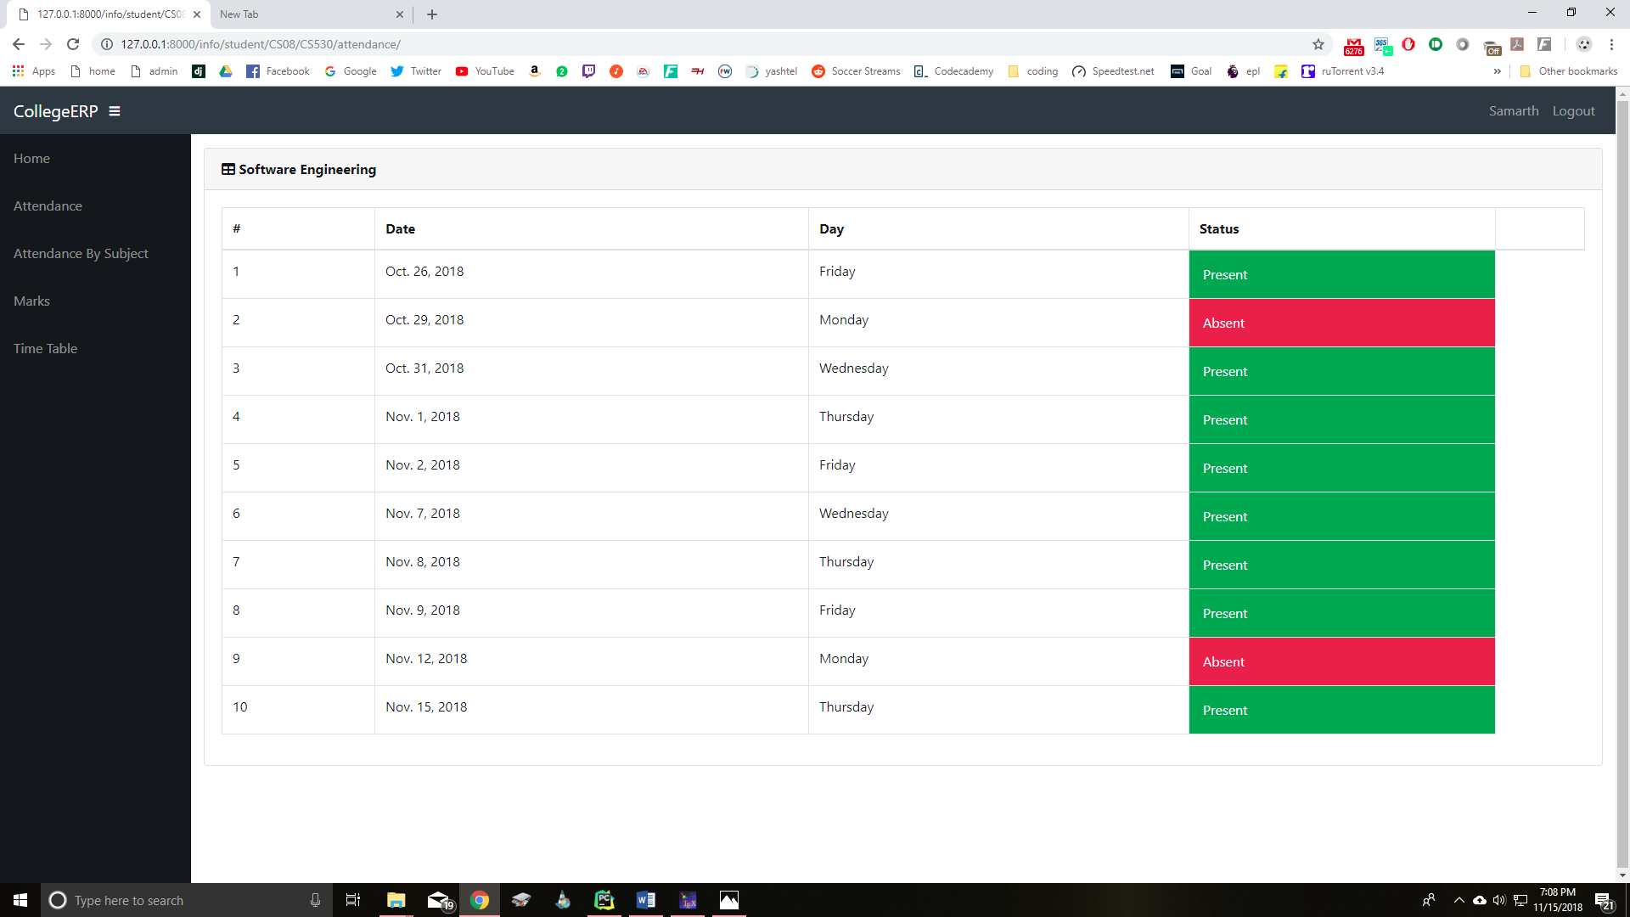

Figure 11: Student Attendance Detail Page

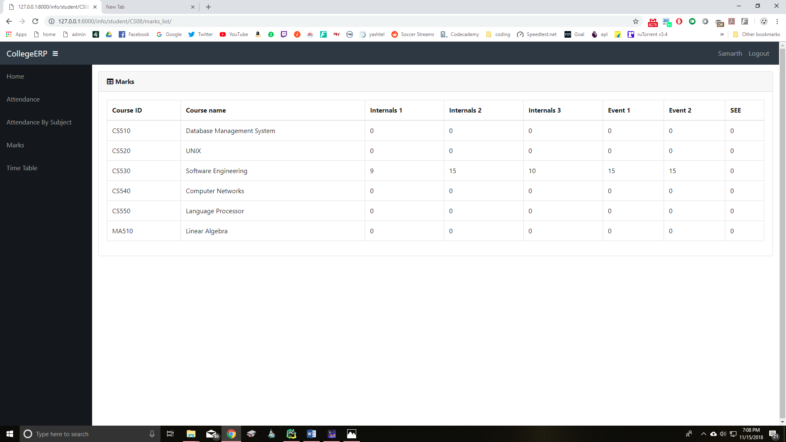

Figure 12: Student Marks Page

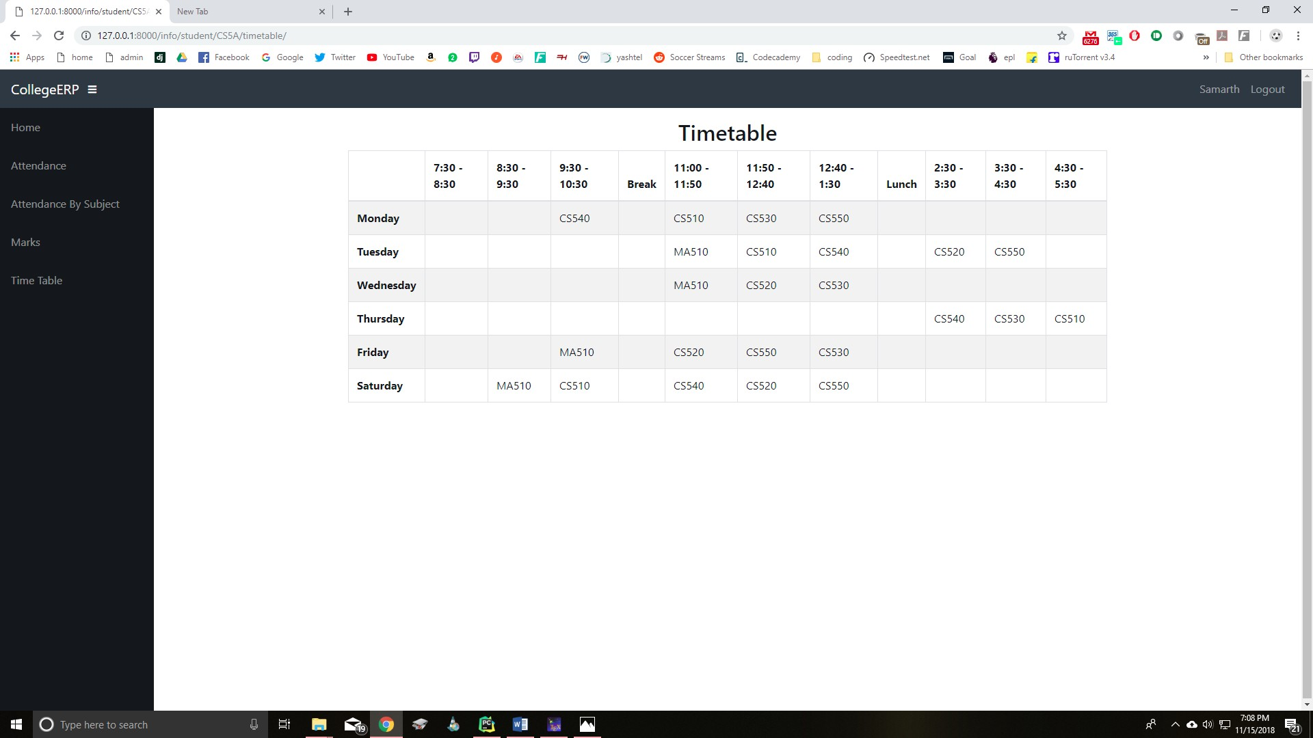

Figure 13: Student Timetable

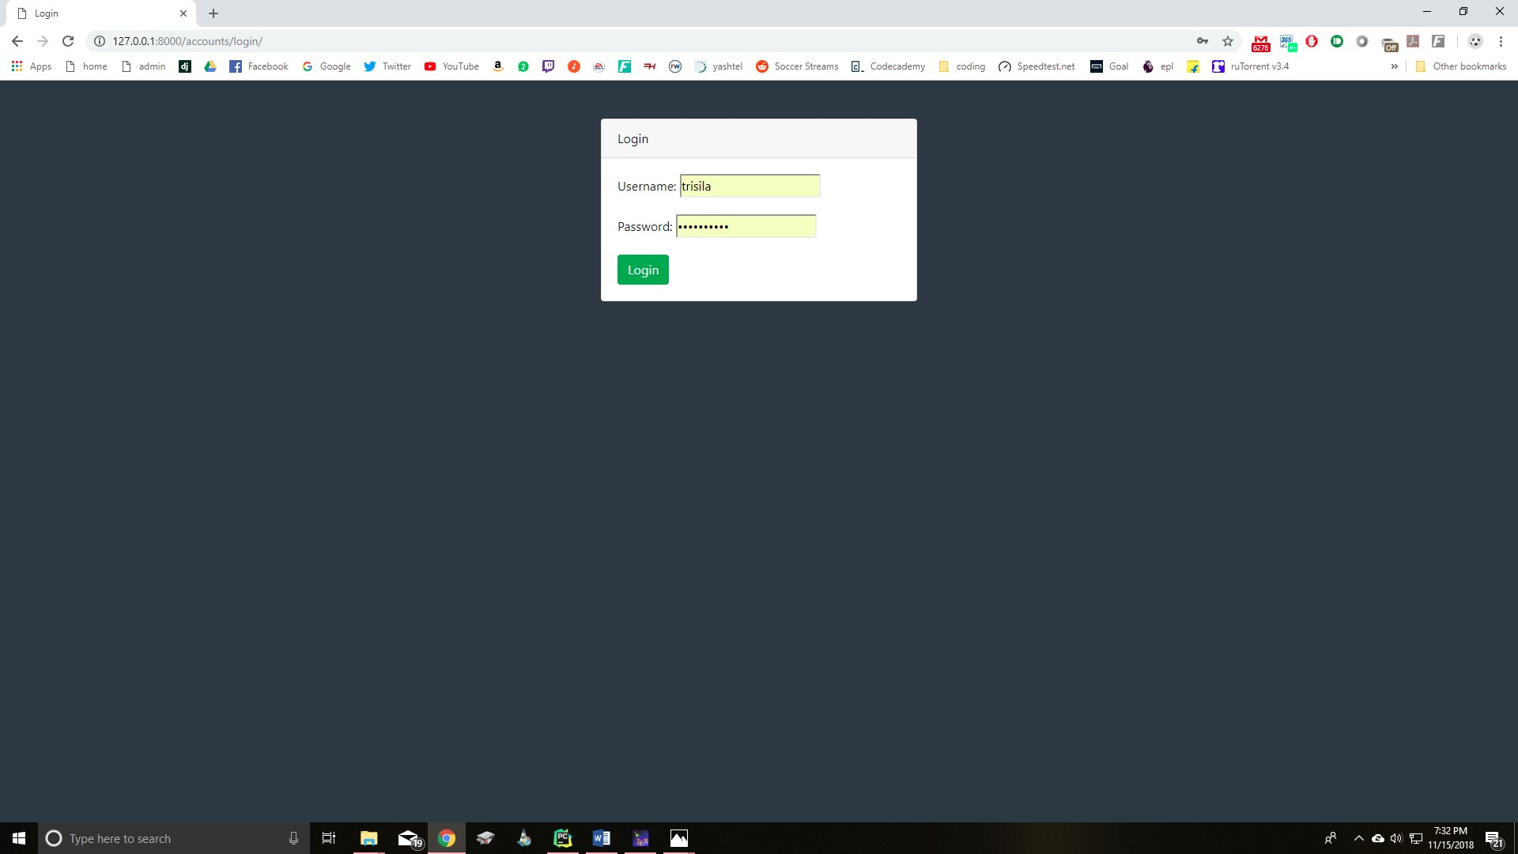

Figure 14: Teacher Login

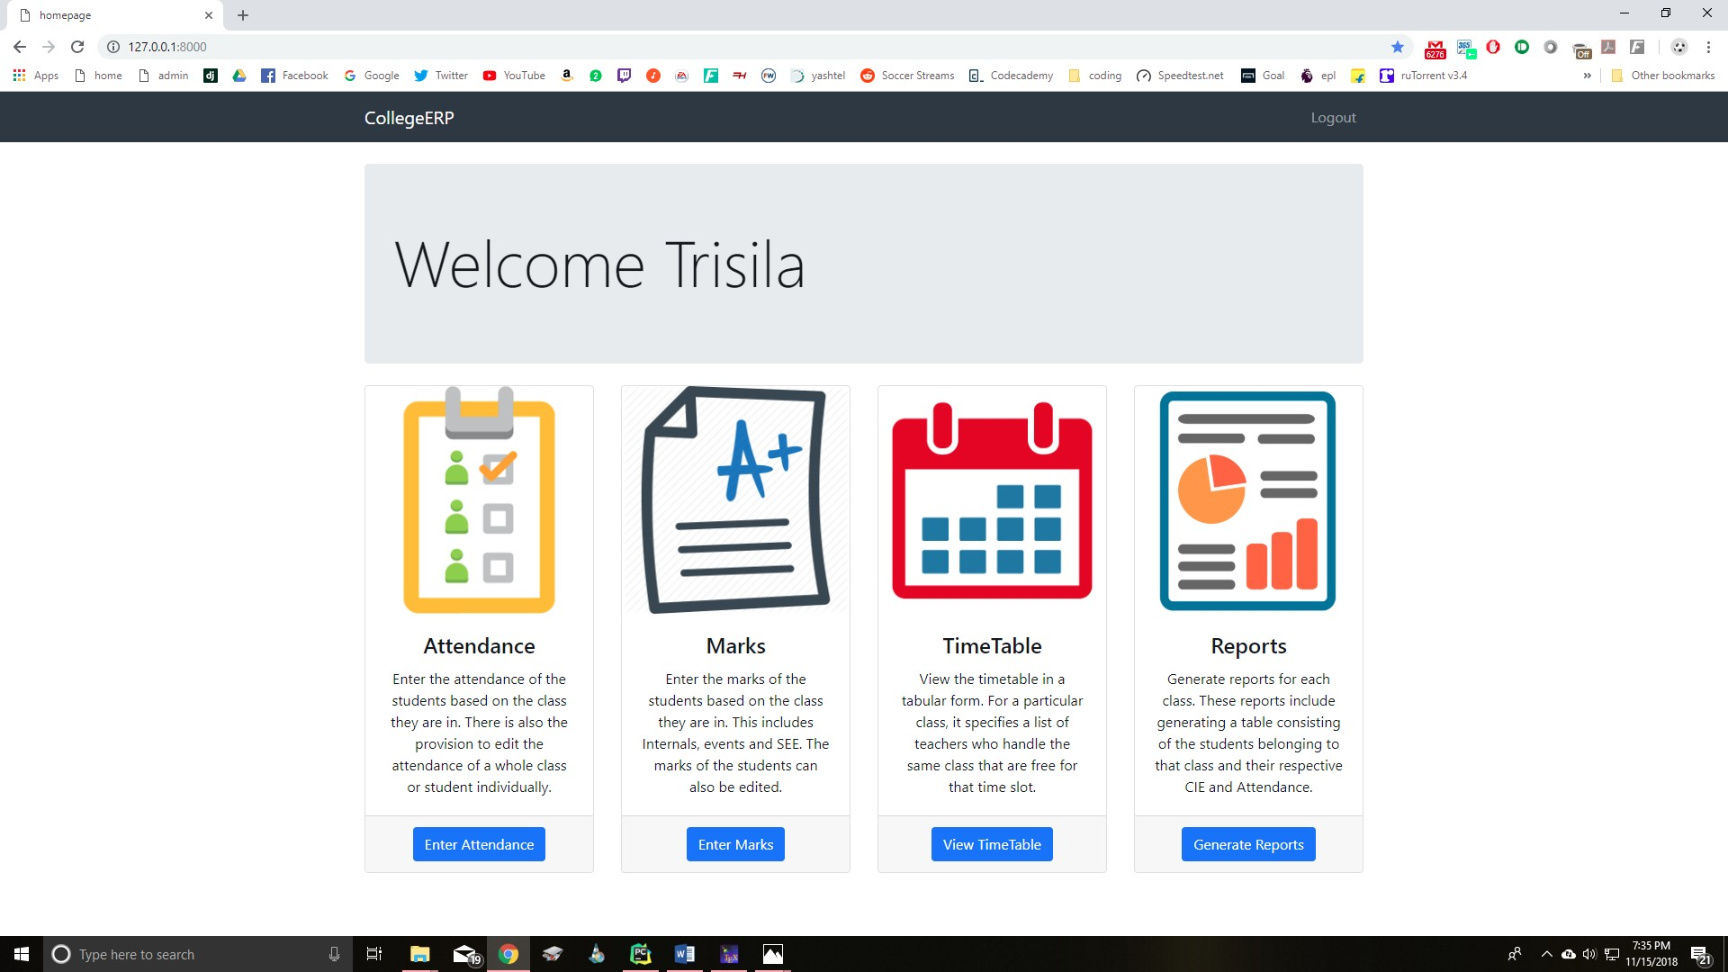

Figure 15: Teacher homepage

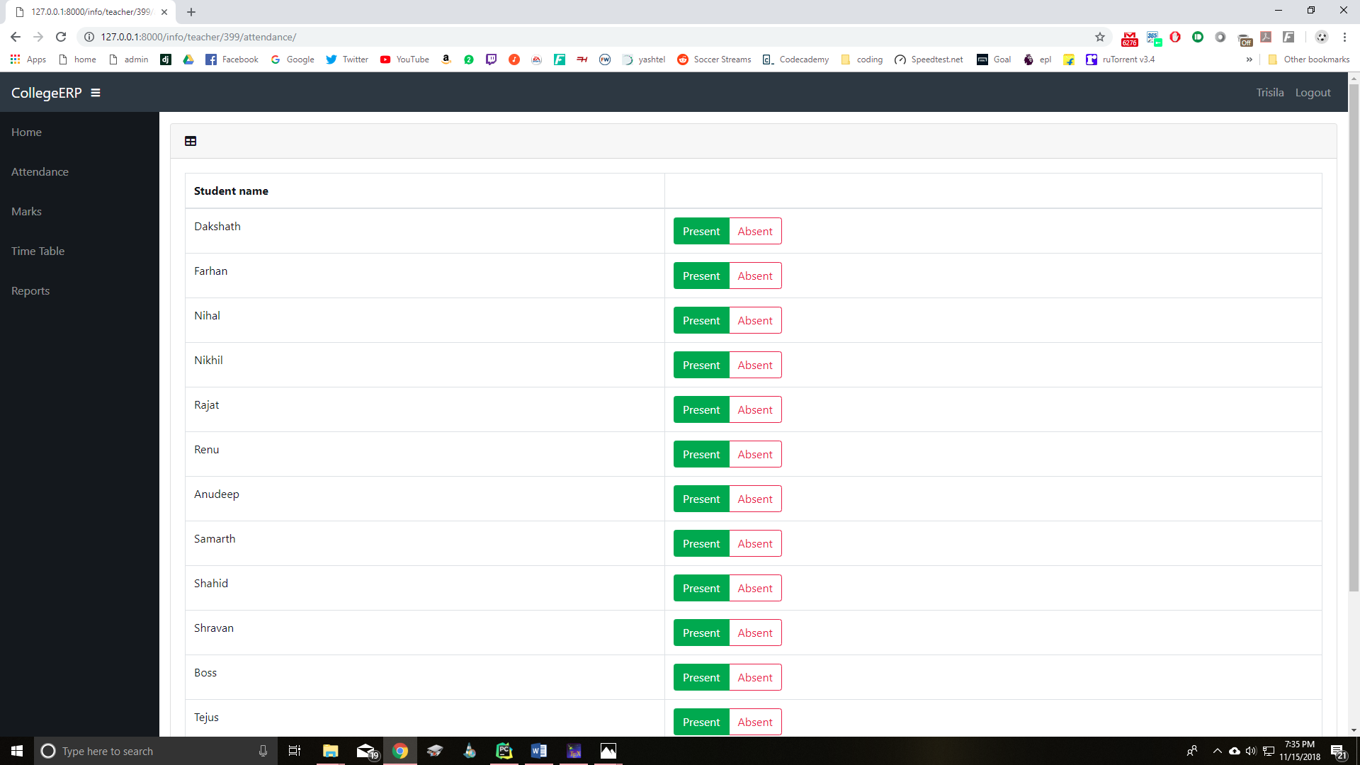

Figure 16: Entering attendance

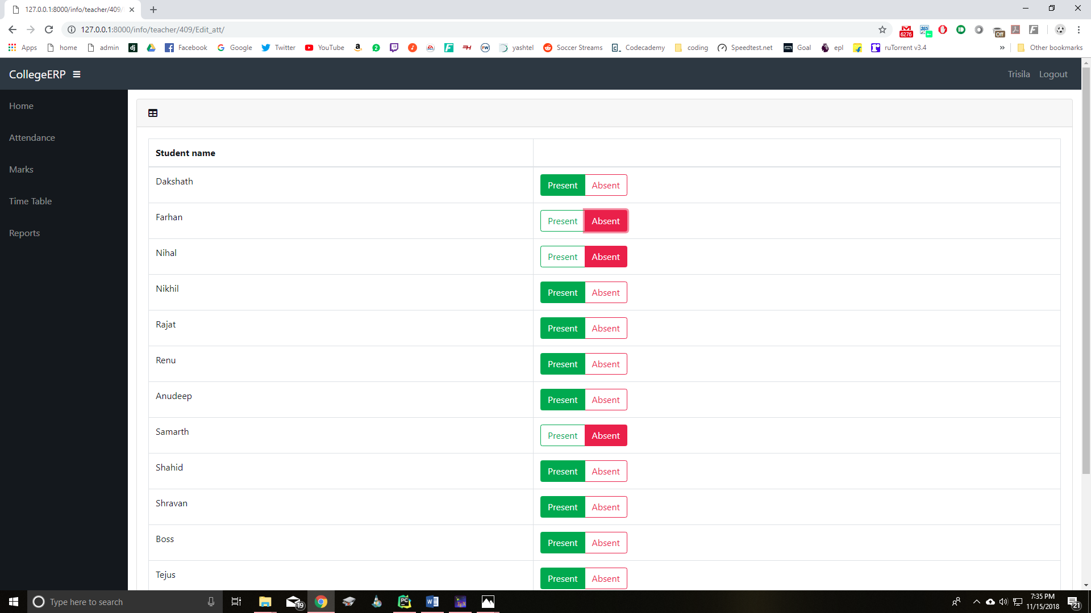

Figure 17: Editing attendance

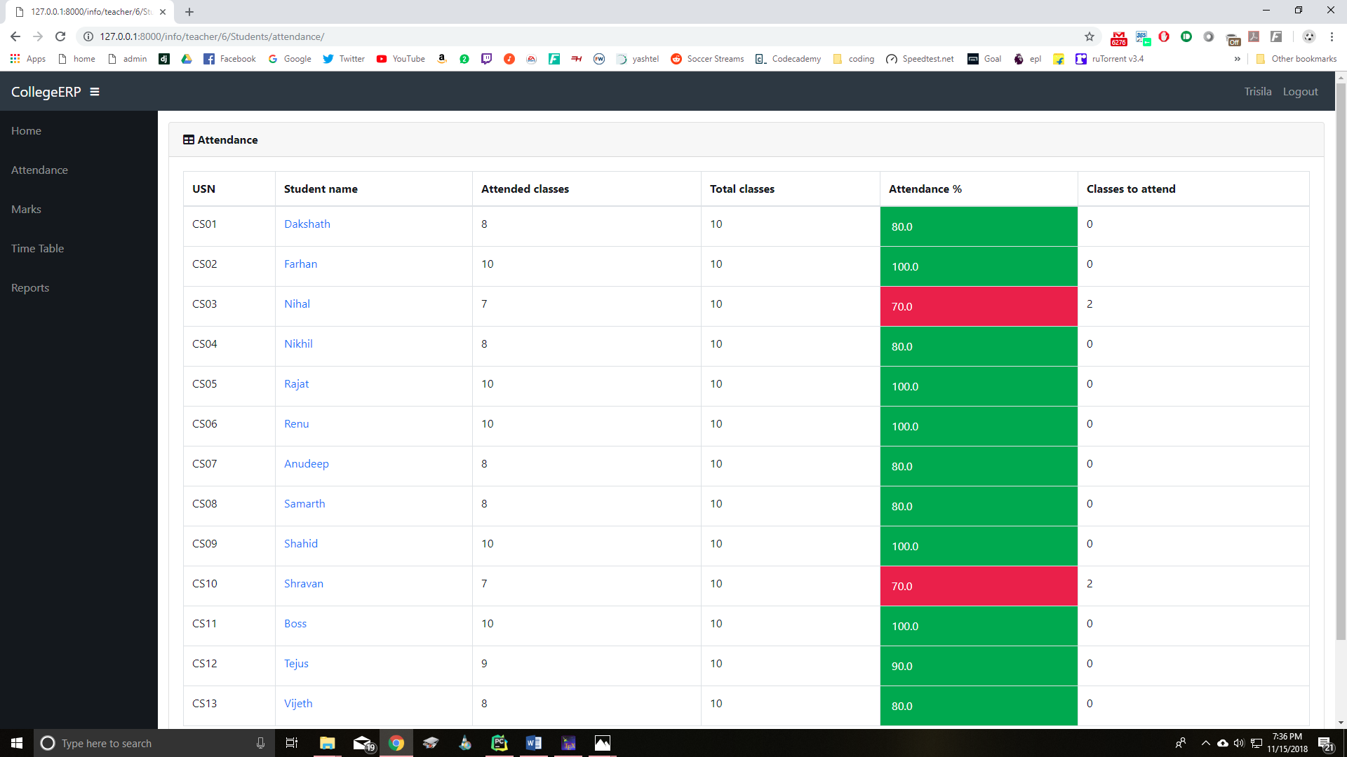

Figure 18: Attendance of students in a class

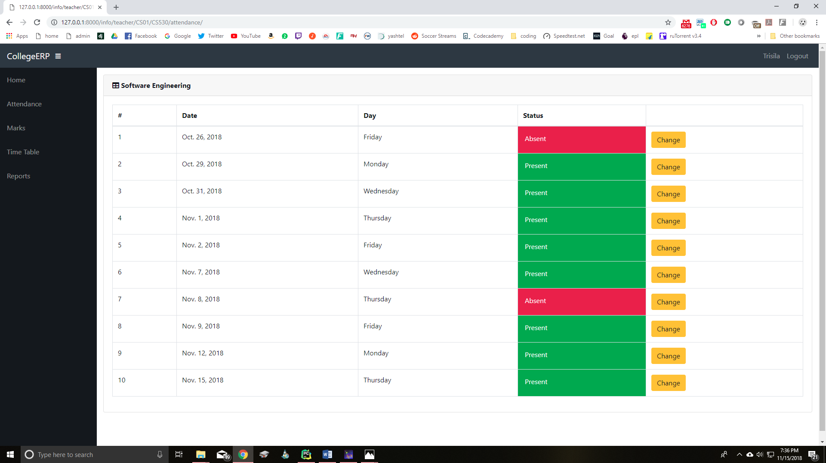

Figure 19: Attendance details of an individual student

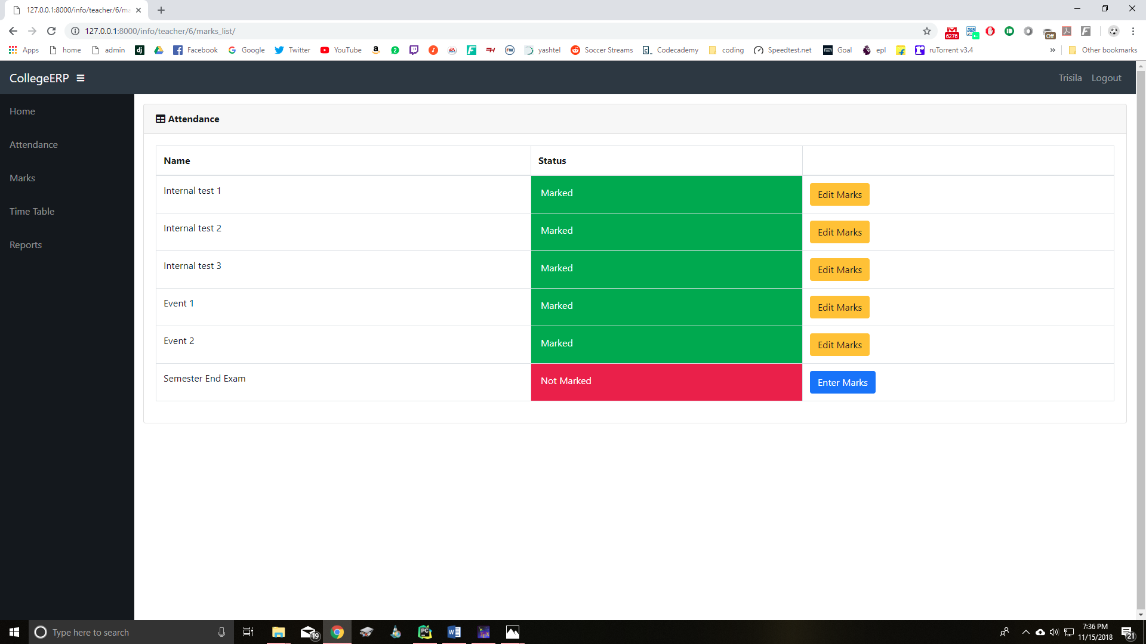

Figure 20: Entering marks

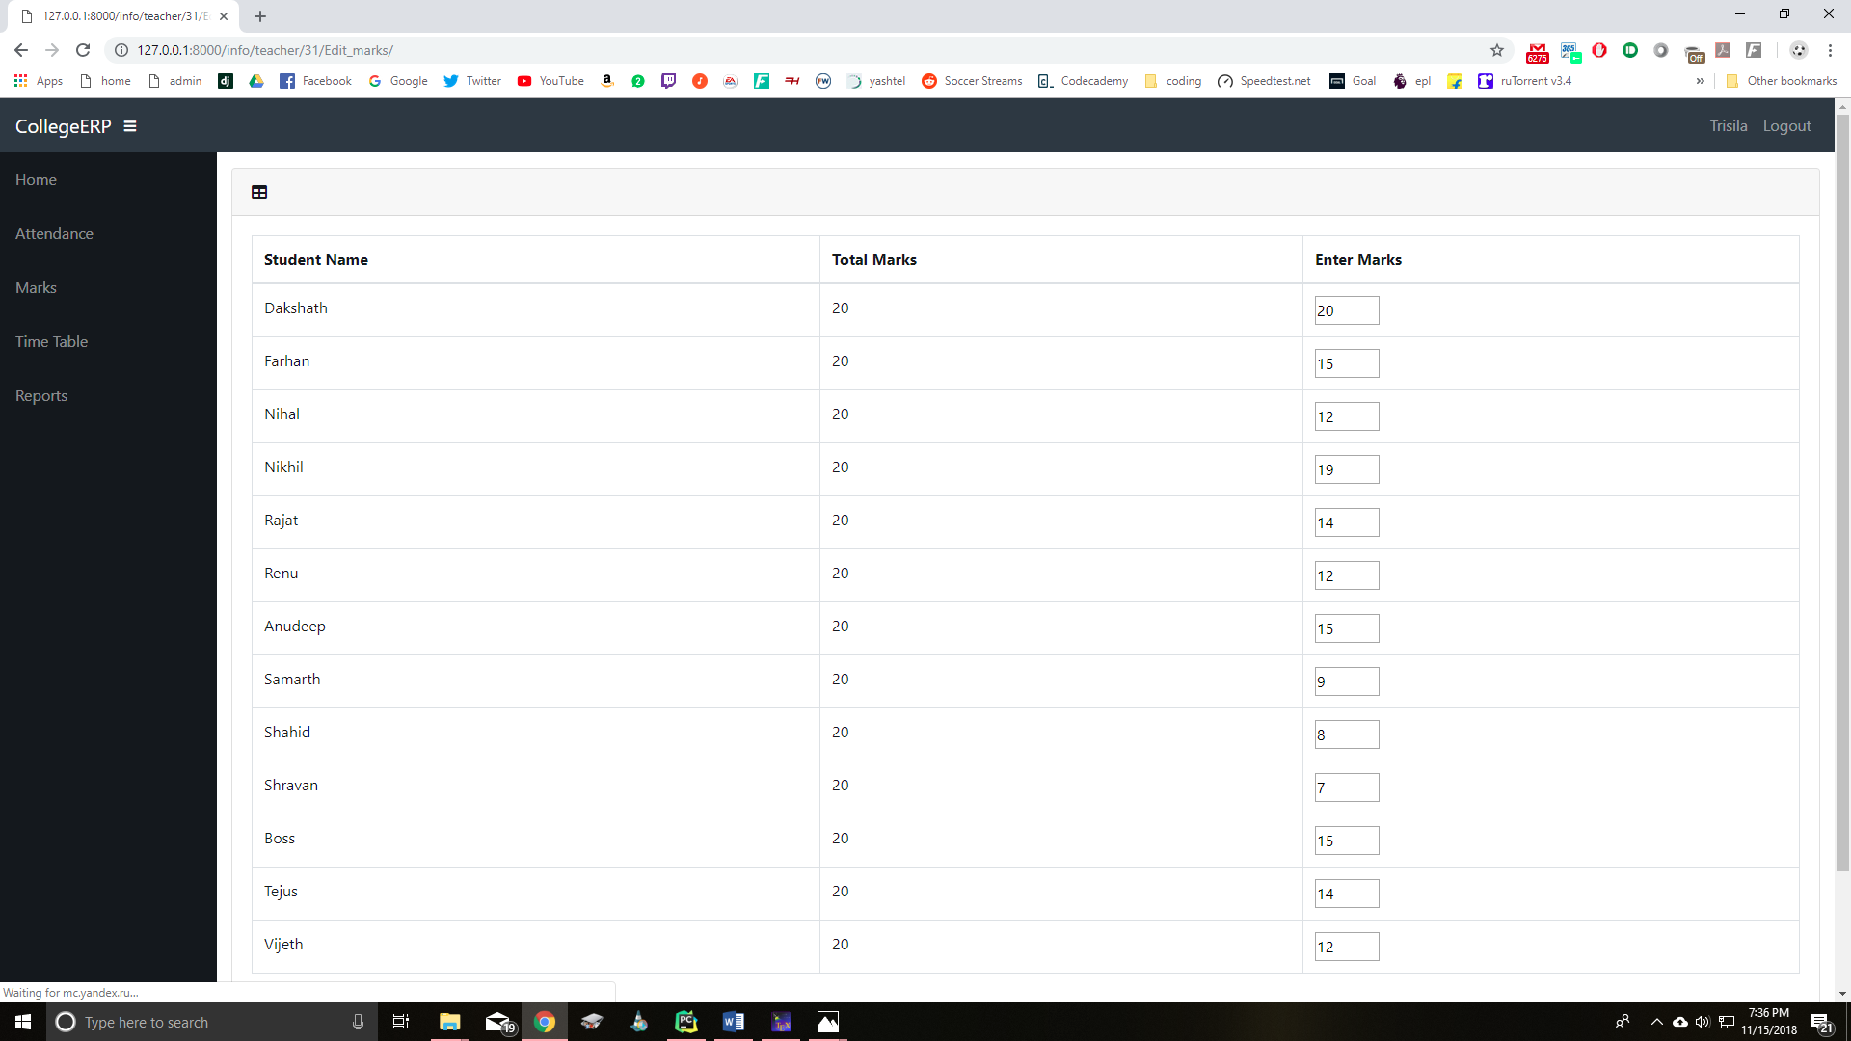

Figure 21: Editing marks

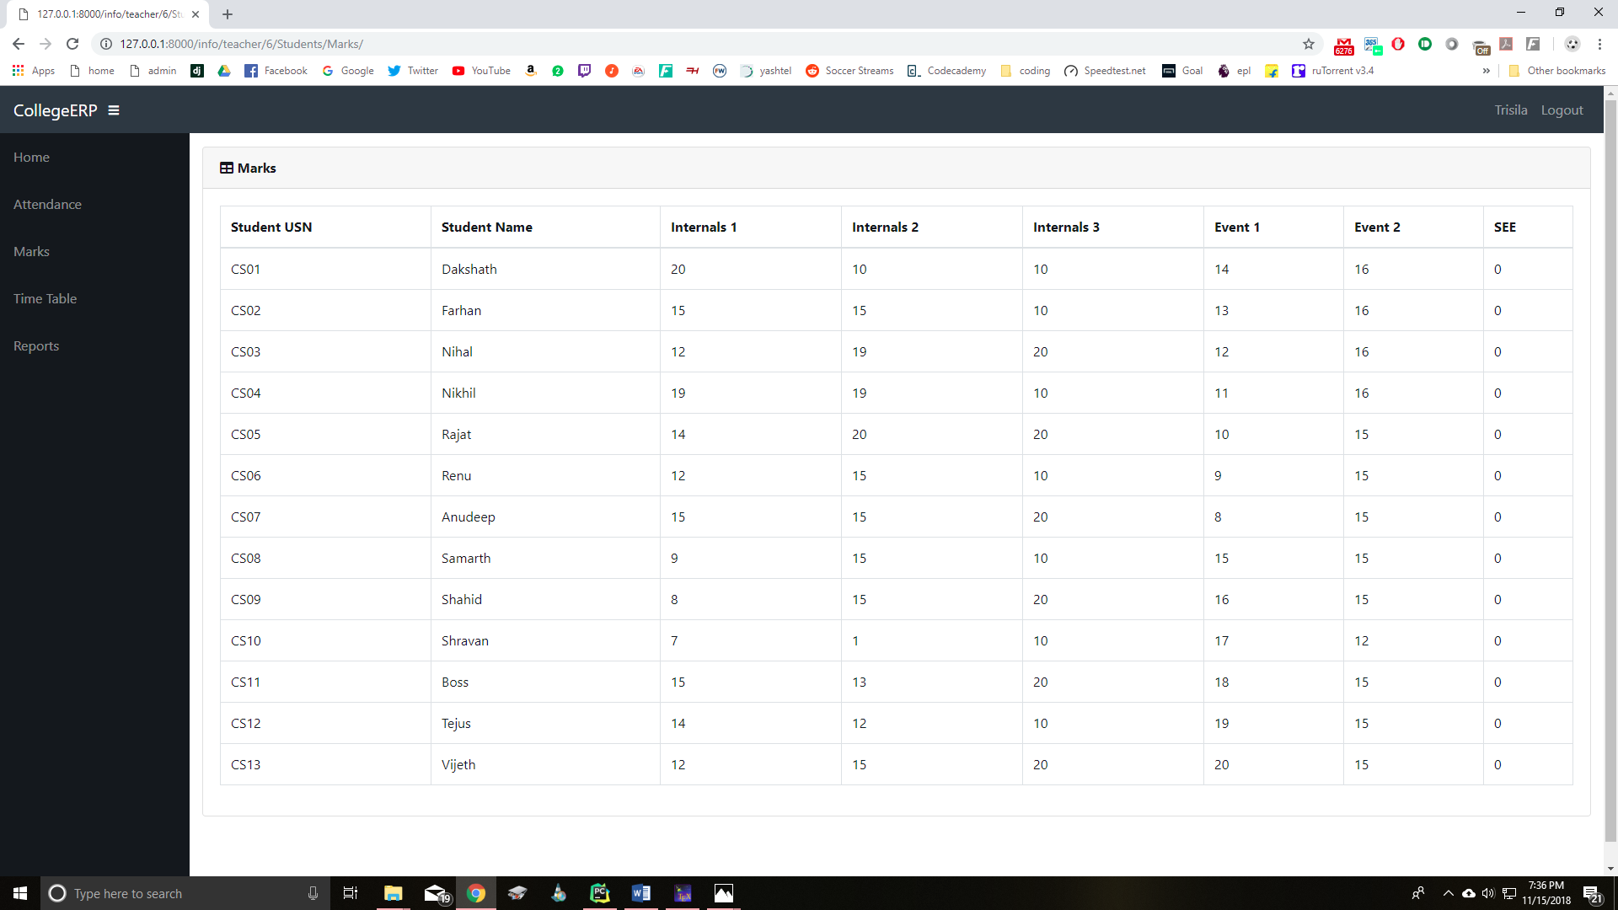

Figure 22: Marks of all the students in a class

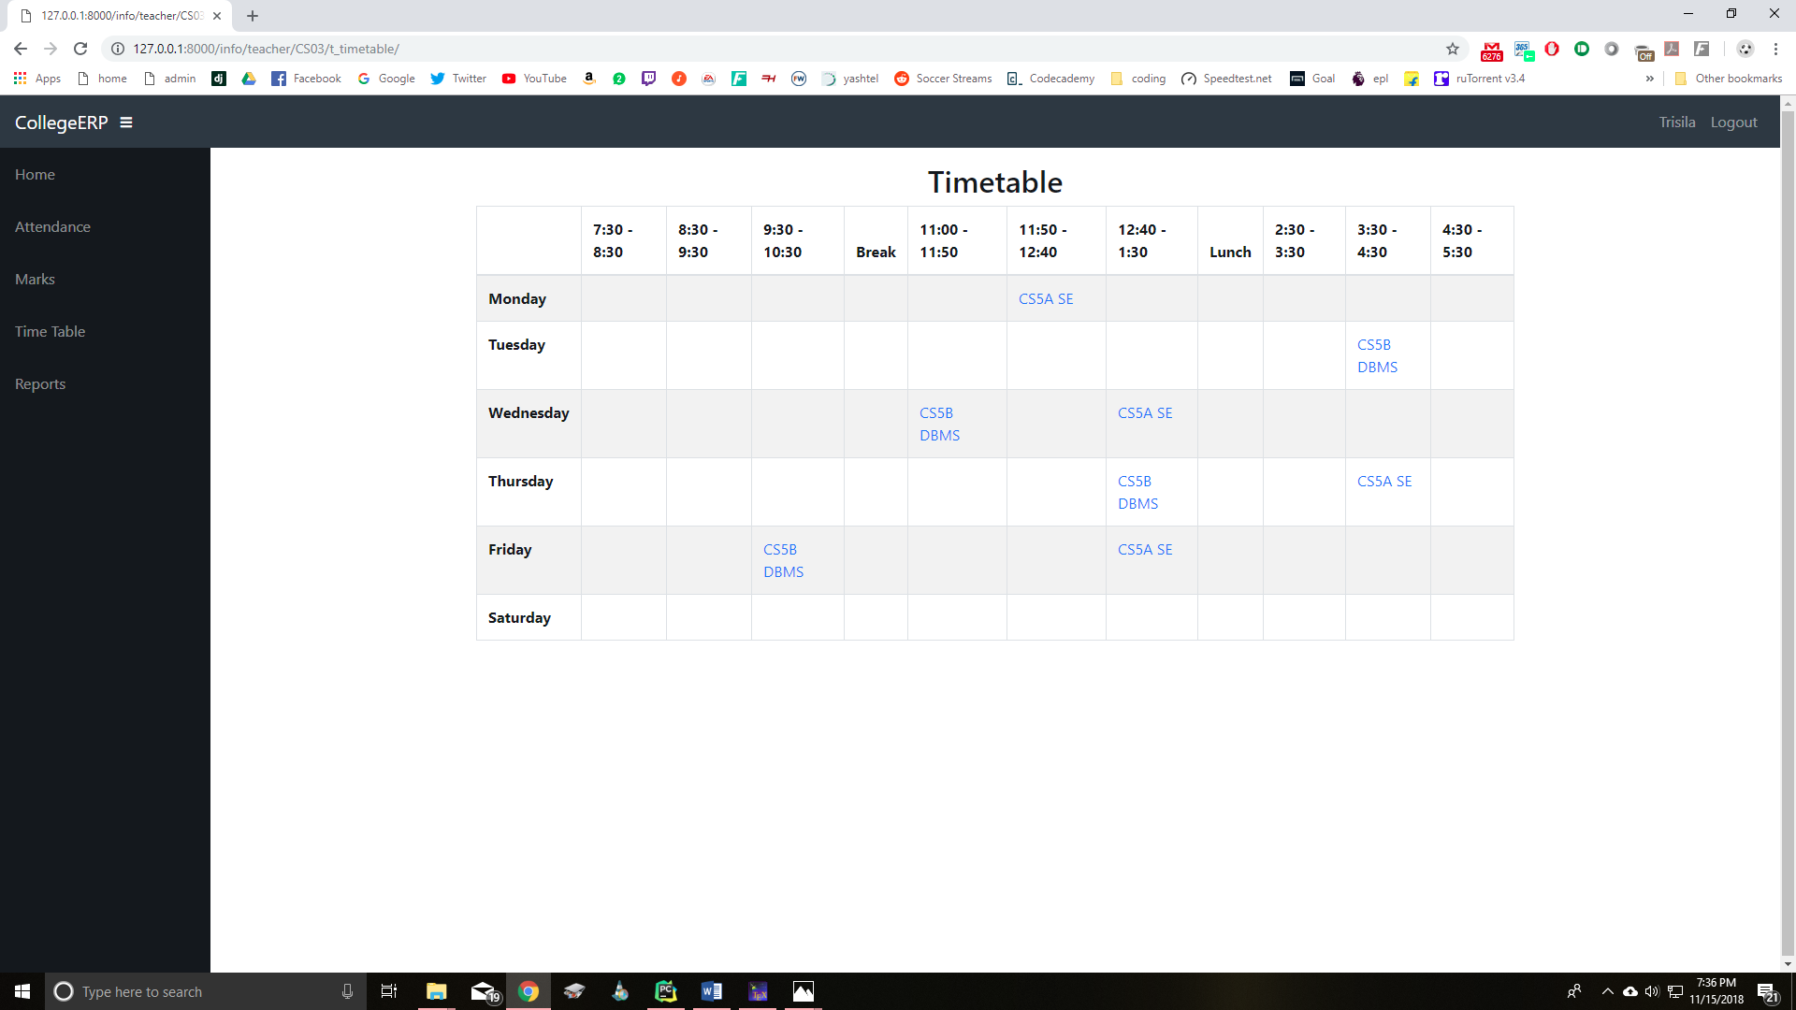

Figure 23: Teacher Timetable

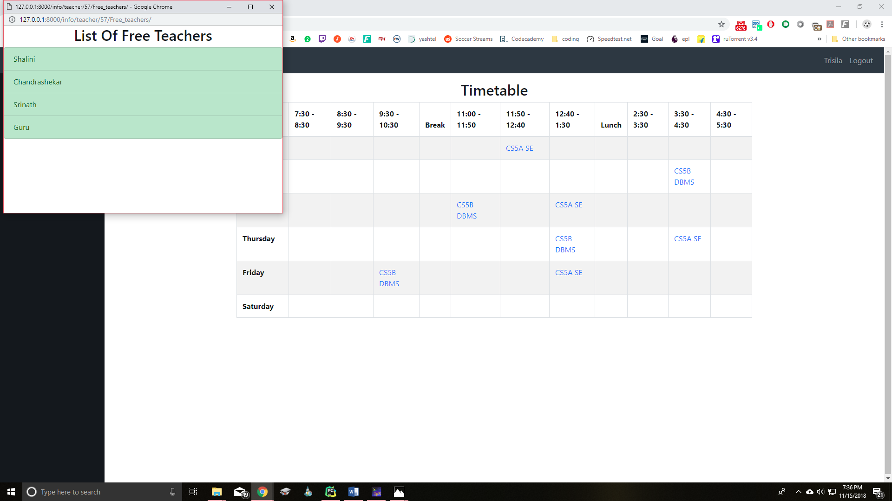

Figure 24: List of free teachers for a time slot

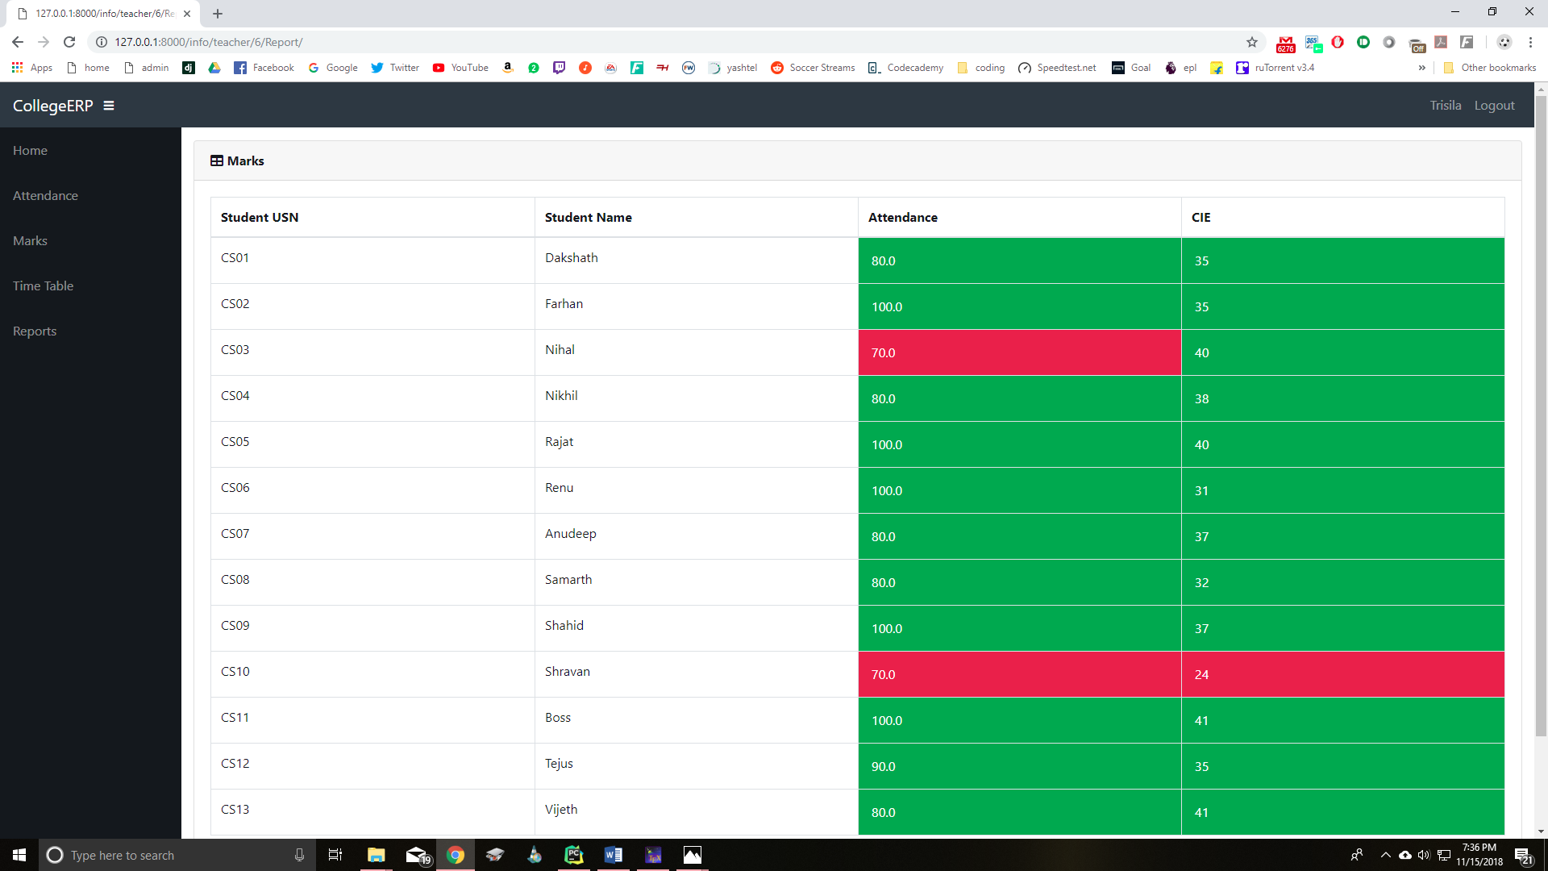

Figure 25: CIE and attendance for a class of students

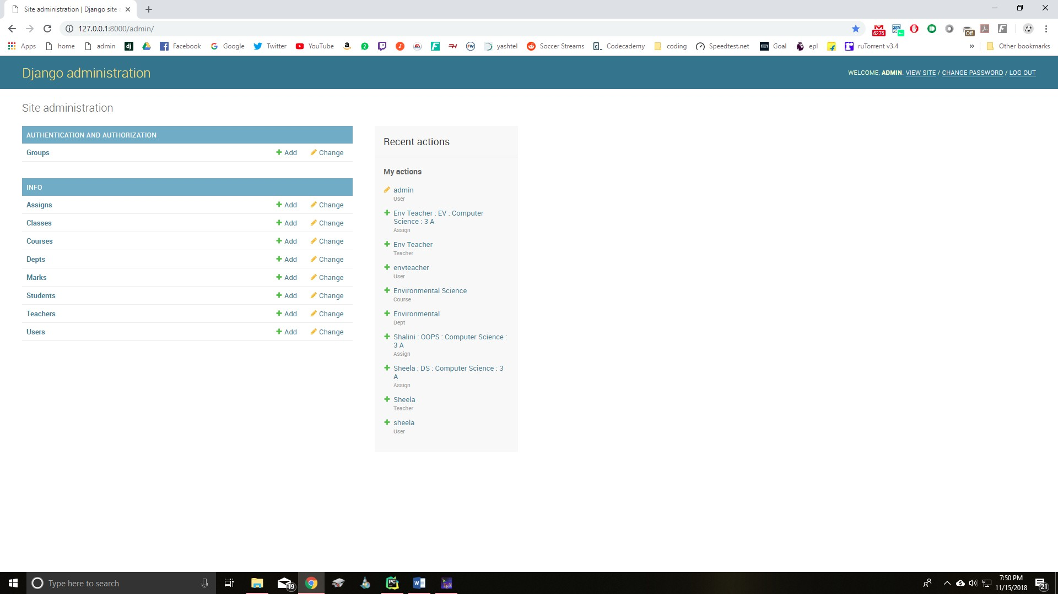

Figure 26: Admin homepage

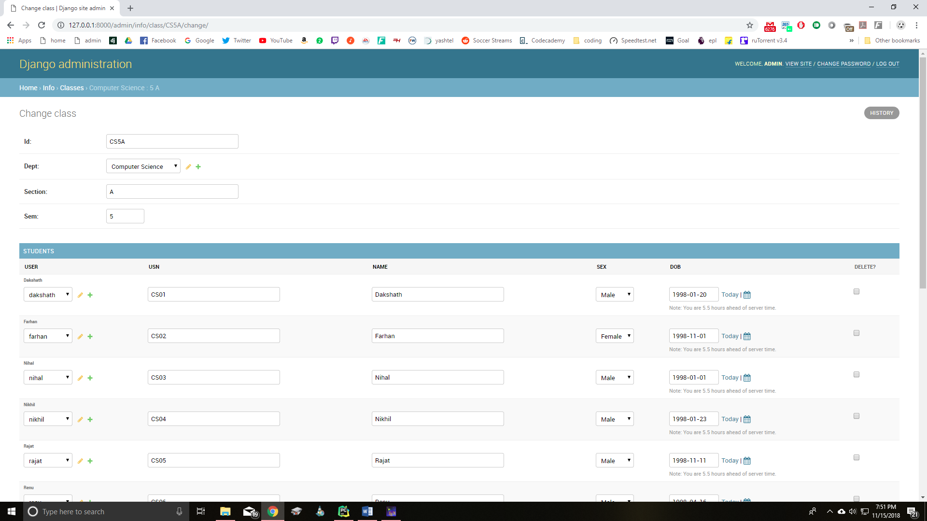

Figure 27: Admin students table page

1. **Conclusion and future work**

By using Existing System accessing information from files is a difficult task and there is no quick and easy way to keep the records of students and staff. Lack of automation is also there in the Existing System. The aim of Our System is to reduce the workload and to save significant staff time.

Title of the project as College ERP System is the system that deals with the issues related to a particular institution. It is the very useful to the student as well as the faculties to easy access to finding the details. The college ERP provides appropriate in- formation to users based on their profiles and role in the system. This project is designed keeping in view the day to day problems faced by a college system.

The fundamental problem in maintaining and managing the work by the administra- tor is hence overcome. Prior to this it was a bit difficult for maintaining the time table and also keeping track of the daily schedule. But by developing this web-based applica- tion the administrator can enjoy the task, doing it ease and also by saving the valuable time. The amount of time consumption is reduced and also the manual calculations are omitted, the reports can be obtained regularly and also whenever on demand by the user. The effective utilization of the work, by proper sharing it and by providing the accurate results. The storage facility will ease the job of the operator. Thus the system developed will be helpful to the administrator by easing his/her task.

This System provide the automate admissions no manual processing is required. This is a paperless work. It can be monitored and controlled remotely. It reduces the man power required. It provides accurate information always.. All years together gathered information can be saved and can be accessed at any time. The data which is stored in the repository helps in taking intelligent decisions by the management providing the accurate results. The storage facility will ease the job of the operator. Thus the system developed will be helpful to the administrator by easing his/her task providing the accu- rate results. The storage facility will ease the job of the operator.

This project is successfully implemented with all the features and modules of the college management system as per requirements.

1. **References**
2. Elmasri and Navathe: Fundamentals of Database Systems, 7th Edition, Pearson Education, 2016.
3. Ian Sommerville: Software Engineering, 10th edition, Person Education Ltd, 2015.
4. Roger S Pressman: Software Engineering- A Practitioners approach,8th edition, McGraw-Hill Publication, 2015.
5. https://en.wikipedia.org/wiki/Requirements-engineering
6. https://web.cs.dal.ca/ hawkey/3130/srs-template-ieee.doc
7. <http://www.ntu.edu.sg/home/cfcavallaro/Reports/Report%20writing.htmTop>
8. https://en.wikipedia.org/wiki/Class diagram
9. h[ttps://www.djangoproject.com/](http://www.djangoproject.com/)
10. https://getbootstrap.com/
11. h[ttps://www.tutorialsp](http://www.tutorialspoint.com/)oin[t.com/](http://www.tutorialspoint.com/)
12. https://creately.com/
13. h[ttps://www.o](http://www.overleaf.com/project)v[erleaf.com](http://www.overleaf.com/project)/pro[ject](http://www.overleaf.com/project)